## Managing Project & Information Security Coursework

Module Co-Ordinator: **Andrew**

Team Members:

* Manuel Cantonero B00228318
* Abubacarr Sillah BannerID
* Mario A. Corchero B00228346

Submision Date: 09-12-2011

## Content

Managing Project & Information Security Coursework

Content

Project overview statement

Background and objectives

Main stakeholders

Assumptions

Project Scope

Request from Twitter

Project Evaluation

Swot Analysis

Investment Appraisal

Project one (E-Shop)

Project A

Project B

Lifecycle Modeling

Option one

Option two

Final decision

Cost Estimate

Work Breakdown Structure

Estimation

Risk Analysis

## 

## 

## Project overview statement

### Background and objectives

Social network has grown popularity beyond imagination, and will continue to grow in much part of the 21st century. This project aims at incorporating virtual shops into social networking site, twitter. The idea of amalgamating social network with e-shops will revolutionize customer experience and give businesses opportunities to reach and sell their products and services to potential customers without having to own and maintain an e-commerce site.

Already millions of people regularly use social networking site, the company recognizes and understands the vast market out there and wants to tap into. This has the potentials to double the size of the company’s productivity in the next 3years.

### Main stakeholders

* twitter as the project sponsor,
* 3 full time experienced enterprise web application developer,
* a project manager,
* an analyst
* an ambassador user

### Assumptions

This project assumes that social networking site is already in existence; our role as developers is to use Service-Oriented-Approach (SOA) technology to enhance the existing infrastructure to include e-shops and allow businesses to create accounts, develop profiles and upload their products’ details and make them available to potential customers for viewing and buying.

The existing hardware system has the capacity to support proposed expansion required for the project. And the proposal is being supported by all the stakeholders including the senior management of twitter social networking site. Base on their expert advice, Twitter will pay £220,000 for the project when its delivered, and expect to get a return of £3,000,000 in three years. However, our department has already got £150,000 left in our budget which should be used to develop the project.

### Project Scope

The setup would have two sets of customers. They are individual customers inclusive of current users and business customers. Individual customers register with the site for free as happening now. However some forms of revenue would be generated from business accounts, but those details would be discuss later.

As part of the business rule and security, only legally registered companies can have a shop profile with the site to sell products and services. Shops can develop and maintain catalogues on their products and services, advertise and accept card payments. All payments should be done through the site. Business should be able to keep track of their sales and produce reports.

Individual customer should be able to conduct catalogue search, buy and also see their transaction history. They should be able to share their experience with other and also provide review.

We considered the following to be out of scope of this project

* Platform for advertisement
* the responsibility of getting the businesses to register with the new development
* Other problem related to the hardware and other infrastructure
* Maintenance and support after final delivery

### Request from Twitter

The company has propose two option of delivering the product

* Product delivery as a whole
* Product delivery in two part
  + Shop profiles (Get £100,000 Payment)
  + Rest of the product (Get rest of the balance, £120,000)

## 

## 

## Project Evaluation

In this section, we used couple of evaluation techniques and presented the results of our evaluations. However, they are not exhaustive as further project evaluation would be required to assess the project status as it proceeds. This is imperative in ensuring that chances of success are increased and expensive mistakes are avoided. We have decided to use SWOT analysis, investment appraisal and life-cycle modeling because they are easily understood, frequently used by company itself and provide good results for our purpose.

### Swot Analysis

We first defined and evaluate the strategic objectives of the project to pave the way for SWOT Analysis technique application. Below are the strategic objectives, through which we identified the ups and down of undertaking the project.

* To incorporating virtual shops into social networking site, twitter
* current infrastructure should support the entire development with minimum additional cost
* Give room for businesses to open shop outlet on the site and list their products for sell
* Allow current and prospective user(customers) to buy from registered shop outlets

|  |  |
| --- | --- |
| **Strengths**   * Existing infrastructure * Expertise in software development for social network * Good number of users already with us * Good financial support * Possibility of integration (social network and e-shop ) * Twitter is a good brand popular in the social network | **Weaknesses**   * It is not straight forward to integrate the proposed system with Twitter * Time limit for development and integration * It will be difficult to streamline information * Security for payment and privacy |
| **Opportunities**   * It is a new concept in the market * It has the tendency to grow very fast * The software does not have geographical limitations * Internet shopping is becoming popular * Other social network like Facebook don’t provide the same business facilities * Other sites like Amazon and EBay don’t provide the same experience to their customers * It gives equal platform for big and small businesses * It increases the business coverage (global) | **Threats**   * Sites like EBay and Amazon are already established * Competition is very high in e-shopping * Similar big companies may antagonise Twitter to get into market * It might be damaging to the Twitter brand and image |

### Investment Appraisal

Twitter has commission us to examine the cost benefit of the following projects

1. Project A
2. Project B
3. E-Shop

Out of these three projects, Twitter is prepared to undertake only one due to financial meltdown in the global economy and the industry. These three projects are competing for funding from Twitter. The company wants to see with detailed analytical proves, the most viable one amongst the three. Below is the results of the cost-benefit analysis of the three projects.

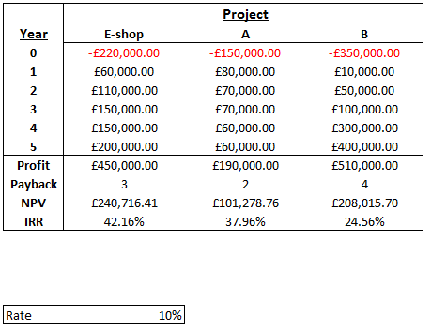

Figure 2.1

If the interest rate is set 10% for the three projects as shown above,

#### Project one (E-Shop)

Base on the table above, E-shop project is expected to cost £220,000, as the second biggest for the three, However, the project will come out with biggest Internal Rate of Return (IRR), with profit of £450,000 in the five year period, the payback within 3 years and highest Net Present Value of £240,716.41.

This project seems more viable from the cost-benefit analysis, in addition, the project would be base on the current enterprise infrastructure and its expert developers. Other important thing that needs consideration is that Twitter already has millions of user who can easily be enticed to use the e-shop.

#### Project A

Project A produces is profitable but is expected to yield the lest profit amongst the three, but it will recoup the cost within two years. Again, bear in mind that it has the lest Net Present Value, but came out second in Internal Rate of Return ranking. One noticeable problem with this project is that the yearly earnings appear constant.

#### Project B

The cost-benefit analysis produced for project B is that the cost is the highest but also the profit toppled the three. The fact that the Internal Rate of Return came out the lowest, with longest payback period and most costly project amongst the three but off the executive. Another problem associated with project B is that it requires a new technology which is not widely available to our user and may take time before it goes down well with the consumers.

Below are the graphical representations of the analysis. They are deemed easy to understand.

Cumulative Cash Flow:

We can see the increase along the years of the different projects. While Project A has a linear increment, our E-shop and Project B have a exponential increment. The conclusion of this Diagram is that we can see how some project increase faster than others, if we should choose one of them, we will choose the Project B.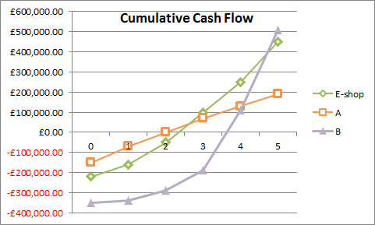

Figure 2.2

Profit: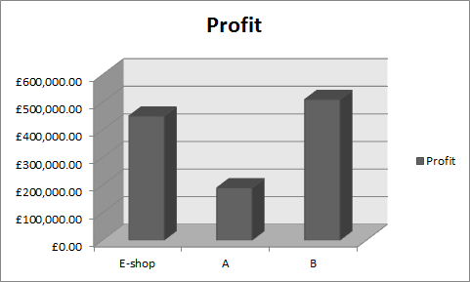

In this diagram we can see how mach money we will earn at the end of the five years. The most profitable is Project B, near to our E-Shop project. In the last place is the Project B.If we should decide for one of then, we should choose the Project B or the E-Shop, cause the Profit is too close. We should not focus only in this one because this value don’t take in account the risk or payback time.

Figure 2.3

Payback: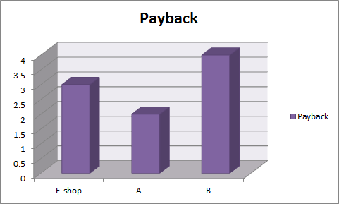

This diagram show years necessary for that project give the money invest them.The first of them is the project A, that only need two years, while the last of them is the project B that need around 4 years for the payback. We should have in mind that the payback value is not the more important, because it doesn’t take account about the profitability.

Figure 2.4

Net Present Value: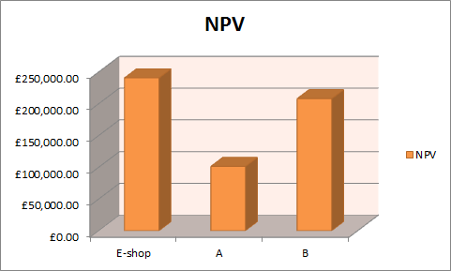

This is a really interesting value to observe because take account about profitability and time of returns, because the later the payback is, the less the money worth. Maybe the only problem of this measure is that doesn’t take account about the risk. As we can see, our project is really interesting over the others.

Figure 2.5

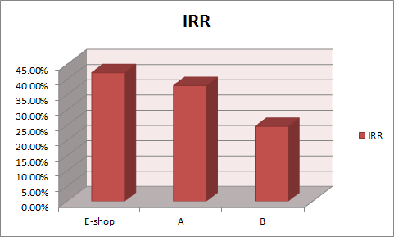

IRR:

This measure could be one of the best because it’s comparable with bank rates. As we can see, our project have an extraordinary IRR.

Figure 2.6

After consultation with the executives including finance department, Twitter opted to support the E-shop project, after taking into account the analysis and other factors intended to undertake

### Lifecycle Modeling

In this section we try to assess two different development methodologies (Waterfall and Incremental ) for the project to enable us to make an informed decision on selecting the most cost-effective approach. Below are the two analyses

For both analysis the monthly budget is £15000 and it is paid in advance, and set the interest rate to 10% taking into account risk factors. However, the incremental approach is longer by month.

#### Option one

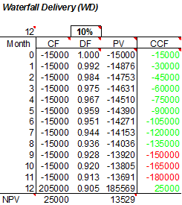

Figure 2.7

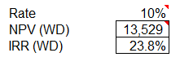

Waterfall approach seems a viable option because its Net Present Value comes out positive and high. In addition to that it Interest Rate of Return is very high which is good for the project. However, there are three months cost exceeds the budget. This could be seen in the table above in red.

#### Option two

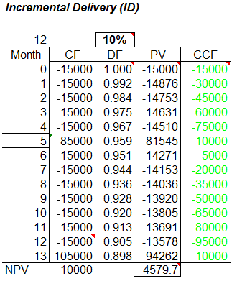

Figure 2.8

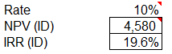

Incremental approach also seems a viable option because its Net Present Value (NPV) comes out positive but not as high as the water fall. In addition to that it Interest Rate of Return is very high too, which is good for the project. Moreover, the budget has covered the whole project cost.

#### Final decision

Base on the analysis we’ve decided to choose second option, Incremental approach. With this option we earn less NVP and low IRR, but our cost is within budget.

## 

## Cost Estimate

#### sWork Breakdown Structure

We have conducted a decomposition of the project into four main tasks,namely Project Initiation, Investigation and Analysis, Design, and Implementation. We further break these main tasks into functional and nonfunctional units so that they can easily be carryout. See figure 3.1. However, we expect to provide milestones (deliverable) as the project progresses, but they are not shown in this diagram, details for the milestones, see the diagram on page.

We have detected the following milestone:

* Feasibility Report:
* Requirement Document:
* Design documents:
* First Software Delivery:
* Configuration Report + Software Delivery:
* Evaluation Report + Final Delivery:

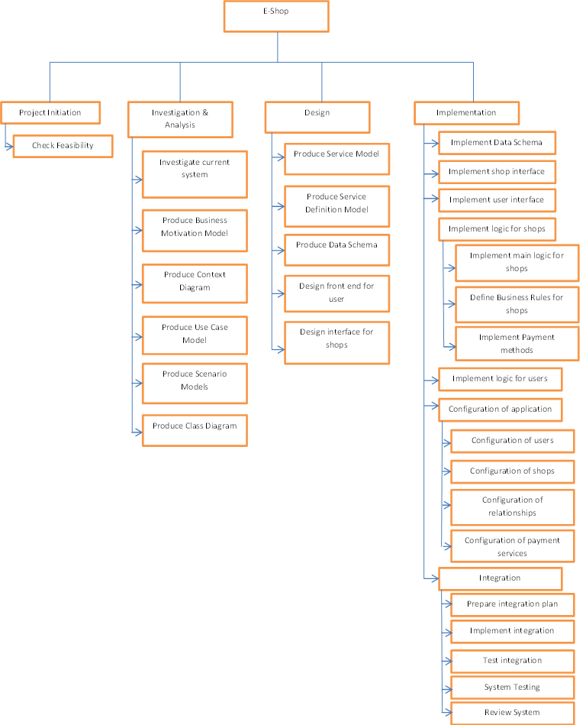

Figure 3.1

#### Estimation

We acknowledge the fact, the company wants the existing enterprise infrastructure to support the proposed development with minimum additional cost, as part of its primary strategic objectives, this prompted us to compile the final cost estimates from five different estimators. Each activity is provided with five possible schedule estimates. Bear in mind that these are expert estimates, who use their experiences from previous projects. We use expert opinion instead of algorithm methods because the company department responsible has got very good expertise in this kind of projects.

We arrived at the final schedule estimates by calculating the mean of the middle three activity schedule estimates by excluding the minimum and maximum schedule presented by our expert estimators for each activity .

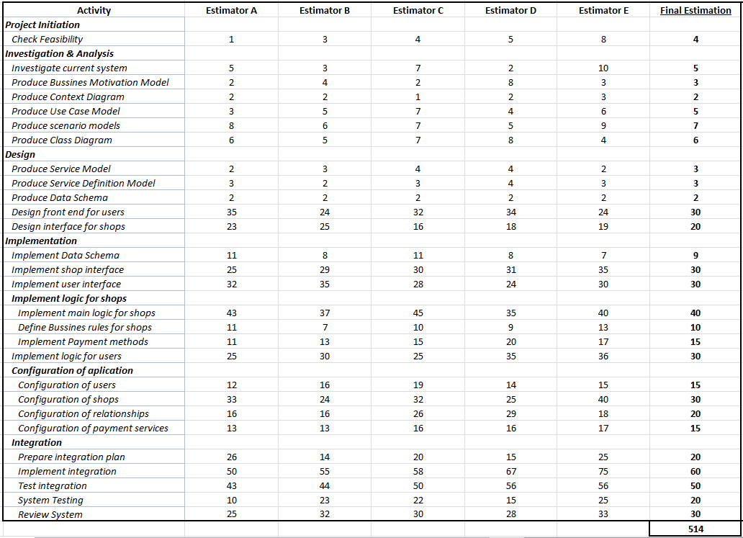

Figure 3.2

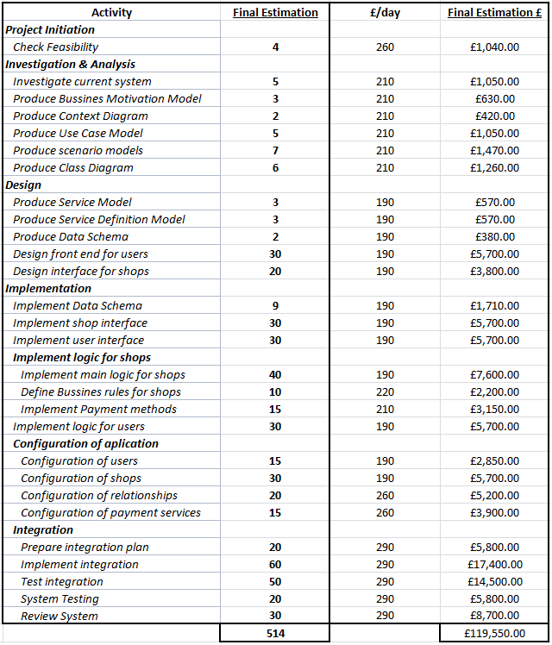

Figure 3.3

## Risk Analysis

Table bellow presented the main anticipated risks that are identified, the possible impact they may cause, and the containment plan we put in place should they occur. We also identify individuals responsible for monitoring them. They most have close eye on them because their implications could be catastrophic to the project cost, time and scope.

|  |  |  |  |  |  |
| --- | --- | --- | --- | --- | --- |
| Risk | Likelihood | Impact | Hazard | Containment plan | Tracker |
| Damage to Twitter brand and image | 5 | 8 | 60% | Good design and implementation, survey and market research, lobby for contract with big shops | Mario, Manuel, Sillah |
| Customer disappointment | 3 | 5 | 30% | Good customer support facilities, | Development team, |
| Over run the budget | 3 | 3 | 10% | Proper control on budget, frequent review of the plan, Finish on time | Mario |
| Refusal from Big companies to register with e-shop | 4 | 7 | 40% | Big campaign, publicity, promotions | Manuel |
| Overload current servers | 1 | 7 | 10% | Purchase more resources | Project manager |
| Transfer of resources to other projects | 5 | 7 | 10% | Delay the deliveries, work overtime | Project Manager |
| Hidden complexity | 2 | 5 | 30% | Control and monitoring | Analyst |
| Security issues with online payment | 2 | 4 | 20% | Choose only the most secure payment methods | Micheal |
| Frequent changes to privacy law | 8 | 2 | 5% | scalable and flexible implemetation | Sillah |
| Natural hazard(Bad weather, snow) | 3 | 3 | 10% | Collaborate on line, Work from home | Manuel |
| Electrical failure | 1 | 5 | 10% | Backup generator | Mario |
|  |  |  |  |  |  |

## Project Schedule

The project has been decomposed into manageable units as shown in figure 3.1. This was further developed in the Microsoft Project Management tool to show required milestones. Project schedules was then incorporated into the work break down in the MS project. Time estimate has been assign to each activity